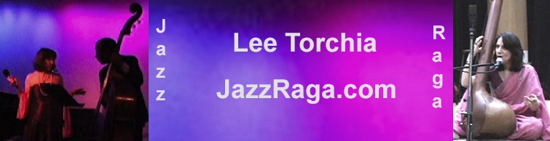 Hindustani Classical Vocal Music

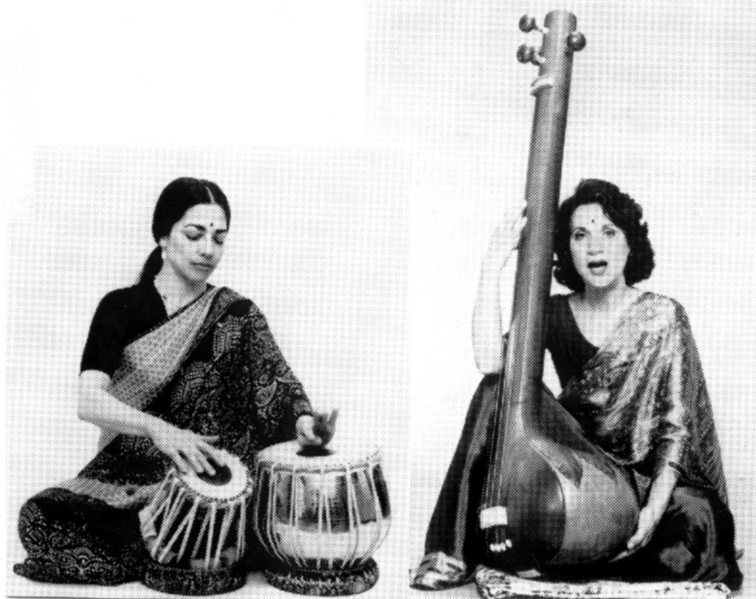
Indian Classical Music, like all the ancient Indian arts, is a spiritual discipline, which expresses mankind's longing for Union with the Divine. This music was developed by mystics living in the ancient forests. They meditated on the 24-hour cycle of nature; watching and listening, observing the movements of the sun, moon, sky, trees, water and wind. These sadhus (holy men and women) discovered special sounds that embodied the passing moment of time. They developed mystical scales (using 22 notes in one octave), and created Ragas (compositions), which evoked the same atmosphere and mood as the passing moment. Thus, certain Ragas are sung only in certain seasons and at certain times of the day or night. For instance, the Raga, Bhairav, is associated with the Dawn and is sung in the early morning (never at night), and the Raga, Megh, is sung only in the rainy season. The performer improvises within the Raga to create a living breathing Spirit of Sound with Devotional intent.
Lee Torchia: Voice &
Tamboura
Misha Msaud: Tabla

The Kirana Gharana (school) is one of the lineages of Hindustani or North Indian Classical Music. In 1293, the great Drupad singer, Gopal Nayak, was captured by a Muslim who conquered Devgiri. Gopal Nayak was considered to be the most valuable treasure, as he was the greatest living Drupad singer of the Krishna Bani, or style of Krishna. He was taken to be a court musician at Delhi, and there he became entranced with the Sufi Saint Khwaja Moinuddin Chishti. Gopal Nayak embraced Islam as well and through the fusion of Hindu and Muslim devotional music, he developed the North Indian Classical Kirana Gharana.

As La Monte Young and Marian Zazeela have written in the program notes for the Pandit Pran Nath Raga Cycle Concerts, a performance of Raga "may consist of any of the following sections:

"1) An introductory or exposition section of the alap without a rhythmic cycle or tabla accompaniment. In Drupad form this section may consist of permutations and combinations of the sequence of the syllables from a line of Vedic text. This is known as Nom Tom style. In Khayal form this section may also be sung in ahkar (Ah-) in which case it is known as Avahan.

The alap section of the raga is considered to be the highest importance. In this slow introductory section all of the characteristic scale structures, melodic patterns and cadences, vadi/samvadi (predominant note/supporting note) relationship, shruti tunings, microtonal shadings and gamaks (ornaments) are exposed. Pandit Pran Nath has often said that the raga is created in between the notes.

- This introductory alap section may be followed by one or more sections in which a fixed composition is sung and improvised upon by the performer demonstrating the shape and nuances of the raga pitches throughout. In vocal music compositions are poetic texts set in a particular rhythmic cycle to a fixed melody created from the pitches of the raga.

Contact: Lee@jazzraga.com 484 West 43 St., #32B, NY, NY 10036 212.695.1906 www.jazzraga.com

